PACIFIC MARINE & INDUSTRIAL®
P.O. Box 70520, Richmond, California, United States 94807-0520
510-233-2310 ◊ info@PacificMarine.net ◊ www.PacificMarine.net

Chain Stoppers for Marine Anchor Chain

Information Needed to Quote

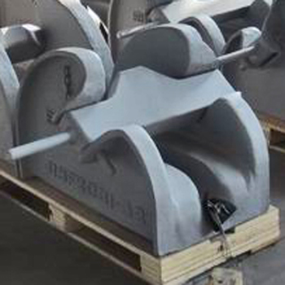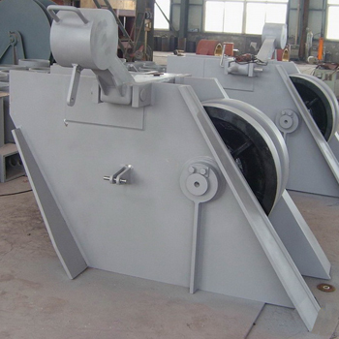
Bar Type Roller Type

1. Type of Chain Stopper: Roller or Bar

2. Size of Chain

3. Grade of Chain: U2, U3, Etc.

4. Quantity Needed

5. Class Society Approved?
What society: ABS, DNV-GL, BC, LR, CCS, Etc.

4. Delivery Location

