PACIFIC MARINE & INDUSTRIAL®
P.O. Box 70520, Richmond, California, United States 94807-0520
510-233-2310 ◊ info@PacificMarine.net ◊ www.PacificMarine.net

Quick Release Hooks

Information Needed for Quotations

Marine Mooring Line Hooks

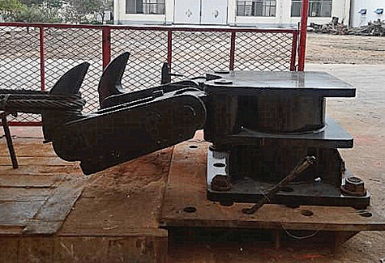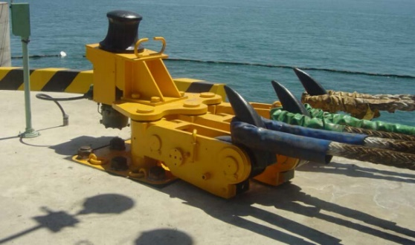
With Manual Release With Integrated Capstan

1. How many Quick Release Hook units are needed in total?

2. What is the hook holding capacity for each hook?

3. How many hooks are included for each unit? (from 1 to 4)

4. Would you like the integrated electric capstan included?
(for pulling in the mooring line messenger line)

5. Are the hooks to be manual or electric release?
(electric release hooks will still have the local manual release)

6. Would you like remote electric release of the hooks?

7. Are there any special requirements?

- Explosion Proof?

- Other?

8. What is the delivery location for the product?

